**Task Description**

Set up a VPC with an Internet gateway, create a public subnet with 256 IP addresses, a private subnet with 256 IP addresses, make a route table connecting the Internet gateway and the subnets, and launch a Linux EC2 instance by using the above VPC and public subnet.

**Step 1: Create VPC**

* Go to the AWS Management Console and open the **VPC** service.
* Click on **Create VPC**.

* **Name Tag**: Enter a name for your VPC (e.g., ***my-vpc-01***).
* **IPv4 CIDR block**: Enter 10.0.0.0/16 (this provides 65,536 IP addresses for the VPC).
* Leave other settings as default and click **Create VPC**.

**Step 2: Create an Internet Gateway**

* In the VPC Dashboard, go to Internet Gateways.

* Click Create Internet Gateway.

* **Name Tag**: Enter a name for the gateway (e.g., ***MyInternetGateway***).
* Click **Create Internet Gateway**.

* Attach the Internet Gateway to the VPC:
* Select the newly created Internet Gateway.
* Click **Actions** → **Attach to VPC**.
* Select your VPC and click **Attach Internet Gateway**.

**Step 3: Create a Public Subnet**

* Go to Subnets in the VPC Dashboard.
* Click Create Subnet.

* **Name Tag:** Enter a name for the subnet (e.g., ***mypublicsubnet***).
* **VPC ID:** Select our VPC.
* **Availability Zone:** Select an AZ (e.g., us-east-2a).
* **IPv4 CIDR block**: Enter 10.0.1.0/24 (256 IP addresses).
* Click Create Subnet.

**Step 4: Create a Private Subnet**

* In the Subnets section, click Create Subnet.
* **Name Tag**: Enter a name for the subnet (e.g., ***myprivatesubnet***).
* **VPC ID:** Select our VPC created
* **Availability Zone:** Select an AZ (e.g., us-east-2a).
* **IPv4 CIDR block:** Enter 10.0.2.0/24 (256 IP addresses).
* Click Create Subnet.

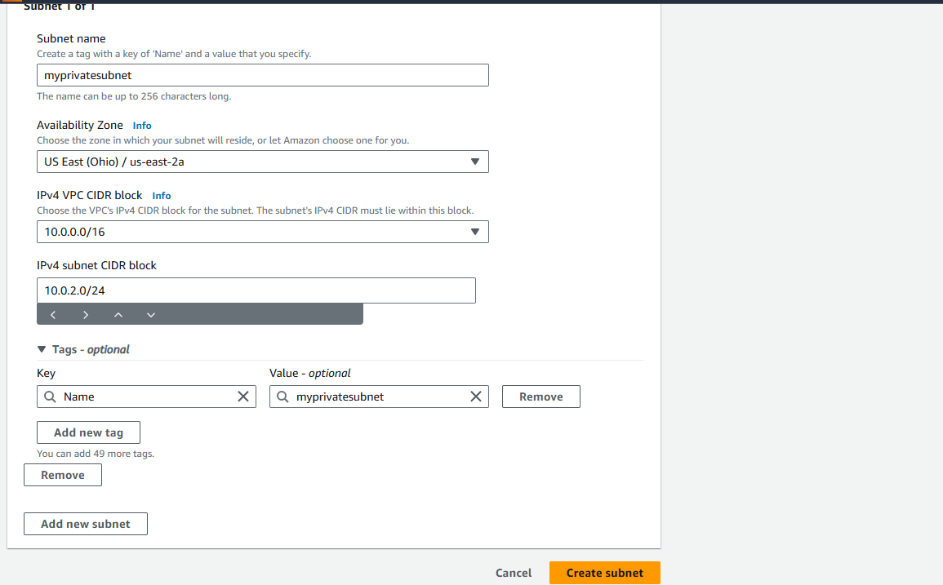

**Step 5: Create a Route Table**

* Go to Route Tables in the VPC Dashboard.
* Click Create Route Table.

* **Name Tag:** Enter a name for the route table (e.g., mypublicroutetable)
* **VPC ID:** Select your VPC.
* Click Create Route Table.

* **Associate the Route Table with the Public Subnet:**
* Select the newly created route table.
* Go to the Subnet Associations tab and click Edit Subnet Associations.
* Select the Public Subnet and click Save.

* **Add a Route for the Internet Gateway:**
* Select the route table.
* Go to the Routes tab and click Edit Routes.

* Add a route:
  + **Destination**: 0.0.0.0/0.
  + **Target**: Select your Internet Gateway.
* Click Save Changes.

**Step 6: Launch an EC2 Instance**

* Go to the EC2 service in the AWS Management Console.
* Click Launch Instance.
* **Name:** Enter a name for the instance (e.g., ***mylinuxinstance01***).
* **AMI:** Select an Amazon Linux 3 AMI (Free Tier eligible).
* **Instance Type:** Select t2.micro (Free Tier eligible).
* Key Pair: Create or select an existing key pair

* **Network Settings:**
* VPC: Select your custom VPC.
* Subnet: Select the Public Subnet.
* Auto-assign Public IP: Ensure this is enabled.

* **Security Group:** Create a new security group:
* Allow SSH (port 22) from your IP or a wider range if necessary.
* Click Launch Instance.

**Step 7: Check the instance creation in the dashboard and its running state**

**Step 8: Connect to instance**

